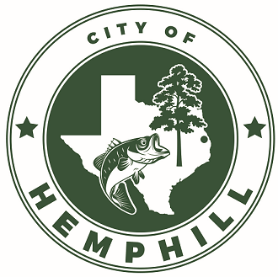

**City of Hemphill – TextMyGov Announcement**

Hemphill is pleased to announce the launch of TextMyGov text alerts, which is a new text messaging service that will provide our residents with important information and updates to keep citizens informed.

Residents may receive text message notifications on things such as Utility Information, Bill Reminders, Election Information, City Council Meeting Information, Emergency Notifications, and other relevant items. Hemphill will officially launch the new text alert system during the week of July 8th. You may receive a text notification from 91896. This will be a legitimate text from the City of Hemphill. Users can opt-out from all texts at any time by texting STOP.

If you did not receive an initial text message, you can choose to opt-in by texting “HEMPHILL” to the number 91896. After sending an initial keyword, users will be asked to reply to the confirmation with a “YES” to opt-in for notifications.

The City of Hemphill is excited for this new technology to keep our residents informed. Other governmental entities across the country are utilizing this system with great success. In the upcoming months, other features will be available to find information and report issues to your local county government offices. More information can be found here: <https://www.cityofhemphill.com/community/page/textmygov-text-messaging-and-notification-system> .

Msg & data rates may apply. Check with your carrier for details. View terms and privacy policy info at: <https://textmygov.com/opt-in-terms-conditions/>